

Foundations of Programming

Assignment No.: 20
PROBLEM STATEMENT: Write a C function to swap two numbers with and without using pointers.

OBJECTIVE:

- To understand the concept of function calls in the C programming language.
- To learn the difference between call by value and call by reference.
- To demonstrate swapping of two numbers with and without pointers.

THEORY:
In the C programming language, swapping two numbers can be performed in two ways: without pointers (call by value) and with pointers (call by reference).

When swapping numbers without pointers, the values are passed to the function by value. This means that a copy of the variables is sent to the function, and any changes made inside the function do not affect the original variables.

When swapping numbers with pointers, the addresses of the variables are passed to the function. This allows the function to directly modify the original variables in memory. Pointers therefore enable efficient data manipulation and are widely used in C for handling memory and complex data structures.
PLATFORM: Linux

INPUT: Two integer numbers.

OUTPUT: Displays swapped values using both call by value and call by reference methods.

CODE:
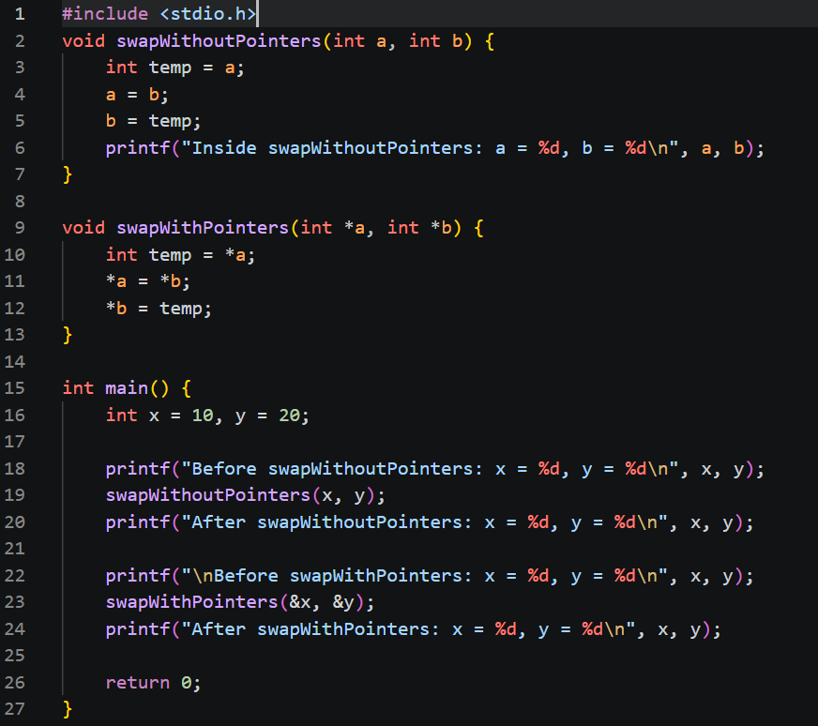

SAMPLE INPUT:
Enter two numbers: 10 20
SAMPLE OUTPUT:
After swapping without pointers:
a = 20 b = 10
After swapping with pointers:
x = 20 y = 10

CONCLUSION: Thus, the C program successfully demonstrates the difference between swapping values using call by value and call by reference. Using pointers allows the function to modify the original variables directly.

FAQs:
- What is the difference between call by value and call by reference in C?
Soln: In C, call by value means passing a copy of the variable to a function, so any changes made inside the function do not affect the original variable. In contrast, call by reference (using pointers) passes the address of the variable, allowing the function to directly modify the original value. Thus, call by value keeps the original data unchanged, while call by reference allows changes to reflect outside the function.
- How do pointers help modify original variables inside a function?
Soln: Pointers help modify original variables by passing the memory address of the variable to a function instead of its value. Inside the function, the pointer is used to access and change the value stored at that address. Since the function works on the actual memory location, any changes made directly affect the original variable.
- Why is swapping using pointers more effective in certain programs?
Soln: Swapping using pointers is more effective because it directly modifies the original variables by working with their memory addresses. This avoids creating copies of data, making it more efficient in terms of memory and performance, especially for large data. It also ensures that the changes persist outside the function, unlike call by value.

